**Course code: CSC-284**

**Lab Report: 02**

**Submitted To**

Tanzina Tasnim Bithi

Department of Computer, Science and Engineering

**Submitted By**

Name: Md.Pranto Ali

ID: 23303101

Section: A

Semester: Fall 2024

Submission date: 02/11/2024 Teacher signature

1. **Arithmetic Operator**

#include <iostream>

using namespace std;

int main() {

int a = 10;

int b = 5;

cout << "Addition: " << a << " + " << b << " = " << (a + b) << endl;

cout << "Subtraction: " << a << " - " << b << " = " << (a - b) << endl;

cout << "Multiplication: " << a << " * " << b << " = " << (a * b) << endl;

cout << "Division: " << a << " / " << b << " = " << (a / b) << endl;

return 0;

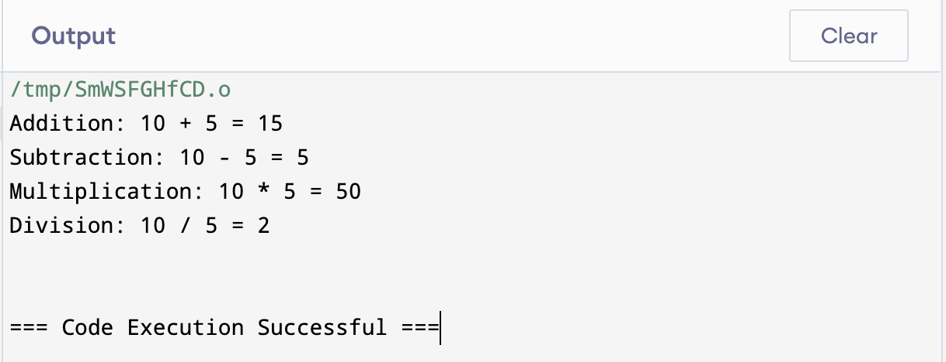}

1. **Relational Operator**

#include <iostream>

using namespace std;

int main() {

int a = 10;

int b = 5;

cout << "Is " << a << " equal to " << b << (a == b ? " Yes" : " No") << endl;

cout << "Is " << a << " not equal to " << b << (a != b ? " Yes" : " No") << endl;

cout << "Is " << a << " greater than " << b << (a > b ? " Yes" : " No") << endl;

cout << "Is " << a << " less than " << b << (a < b ? "Yes" : "No") << endl;

return 0;

}

1. **Logical Operator**

#include <iostream>

using namespace std;

int main() {

int age;

bool isCitizen;

cout << "Enter your age: ";

cin >> age;

cout << "Are you a citizen? (1 for Yes, 0 for No): ";

cin >> isCitizen;

if (age >= 18 && isCitizen) {

cout << "You are eligible to vote." << endl;

} else {

cout << "You are not eligible to vote." << endl;

}

return 0;

}

1. **Bitwise Operator**

#include <iostream>

using namespace std;

int main() {

int a = 10;

int b = 4;

cout << "AND: " << a << " & " << b << " = " << (a & b) << endl;

cout << "OR: " << a << " | " << b << " = " << (a | b) << endl;

cout << "XOR: " << a << " ^ " << b << " = " << (a ^ b) << endl;

cout << "NOT: ~" << a << " = " << ~a << endl;

cout << "Left Shift: " << a << " << 1 = " << (a << 1) << endl;

cout << "Right Shift: " << a << " >> 1 = " << (a >> 1) << endl;

return 0;

}

1. **Assignment Operator**

#include <iostream>

using namespace std;

int main() {

int x = 10;

cout << "Initial value of x: " << x << endl;

x = x + 5;

cout << "After adding 5: " << x << endl;

x = x - 3;

cout << "After subtracting 3: " << x << endl;

x = x * 2;

cout << "After multiplying by 2: " << x << endl;

x = x / 4;

cout << "After dividing by 4: " << x << endl;

return 0;

}

1. **Program to Print the Area and Perimeter of a Circle and Rectangle**

#include <iostream>

using namespace std;

int main() {

float radius;

const float PI = 3.14159;

cout << "Enter the radius of the circle: ";

cin >> radius;

float circle_area = PI * radius * radius;

float circle_perimeter = 2 * PI * radius;

cout << "\nCircle Area: " << circle_area << endl;

cout << "Circle Perimeter: " << circle_perimeter << endl;

float length, width;

cout << "\nEnter the length and width of the rectangle: ";

cin >> length >> width;

float rectangle_area = length * width;

float rectangle_perimeter = 2 * (length + width);

cout << "\nRectangle Area: " << rectangle_area << endl;

cout << "Rectangle Perimeter: " << rectangle_perimeter << endl;

return 0;

}

1. **Basic calculator used Switch case**

#include <iostream>

using namespace std;

int main() {

char operation;

double num1, num2;

cout << "Enter First numbers: ";

cin >> num1;

cout << "Enter operator (+, -, *, /): ";

cin >> operation;

cout << "Enter Secound numbers: ";

cin >> num2;

switch(operation) {

case '+':

cout << "Result: " << (num1 + num2) << endl;

break;

case '-':

cout << "Result: " << (num1 - num2) << endl;

break;

case '*':

cout << "Result: " << (num1 * num2) << endl;

break;

case '/':

if (num2 != 0) {

cout << "Result: " << (num1 / num2) << endl;

} else {

cout << "Error: Division by zero is not allowed." << endl;

}

break;

default:

cout << "Error: Invalid operator." << endl;

break;

return 0;

}

1. **Basic calculator used if,** **else if and else**

#include <iostream>

using namespace std;

int main() {

char operation;

double num1, num2;

cout << "Enter The First numbers: ";

cin >> num1;

cout << "Enter operator (+, -, *, /): ";

cin >> operation;

cout << "Enter The Secound numbers: ";

cin >> num2;

if (operation == '+') {

cout << "Result: " << (num1 + num2) << endl;

}

else if (operation == '-') {

cout << "Result: " << (num1 - num2) << endl;

}

else if (operation == '*') {

cout << "Result: " << (num1 * num2) << endl;

}

else if (operation == '/') {

if (num2 != 0) {

cout << "Result: " << (num1 / num2) << endl;

} else {

cout << "Error: Division by zero is not allowed." << endl;

}

}

else {

cout << "Error: Invalid operator." << endl;

}

return 0;

}

1. **Program to Check if a Number is Positive, Negative, or Zero**

#include <iostream>

using namespace std;

int main() {

int number;

cout << "Enter a number to check: ";

cin >> number;

if (number > 0) {

cout << "The number " << number << " is positive." << endl;

} else if (number < 0) {

cout << "The number " << number << " is negative." << endl;

} else {

cout << "The number is zero." << endl;

}

return 0;

}

1. **Program to Find the ASCII Value of a Character**

#include <iostream>

using namespace std;

int main() {

char character;

cout << "Enter a character: ";

cin >> character;

int ascii_value = static_cast<int>(character);

cout << "The ASCII value of '" << character << "' is " << ascii_value << endl;

return 0;

}

1. **Print a partan**

#include <iostream>

using namespace std;

int main() {

int rows;

cout << "Enter the number of rows: ";

cin >> rows;

for (int i = 1; i <= rows; ++i) {

for (int j = 1; j <= i; ++j) {

cout << "* ";

}

cout << endl;

}

return 0;

}

1. **Peramid partan**

#include <iostream>

using namespace std;

int main() {

int rows;

cout << "Enter the number of rows: ";

cin >> rows;

for (int i = 1; i <= rows; ++i) {

for (int j = 1; j <= rows - i; ++j) {

cout << " ";

}

for (int k = 1; k <= (2 * i - 1); ++k) {

cout << "*";

}

cout << endl;

}

return 0;

}

